Glossary
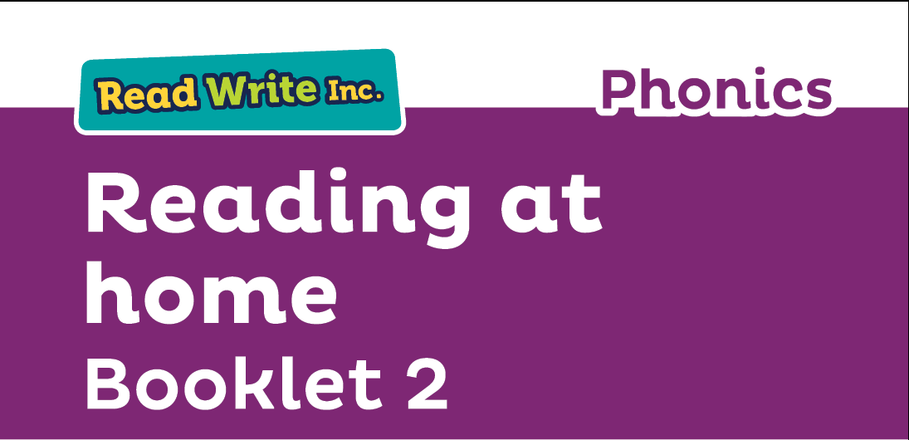
Fred Talk – sounding out the word before reading (blending)

sound-blending – putting sounds together to make a word,
e.g. c–a–t cat

special friends – sounds written with more than one letter,
  - sh, ng, qu, ch

Speed Sounds – the individual sounds that make up words

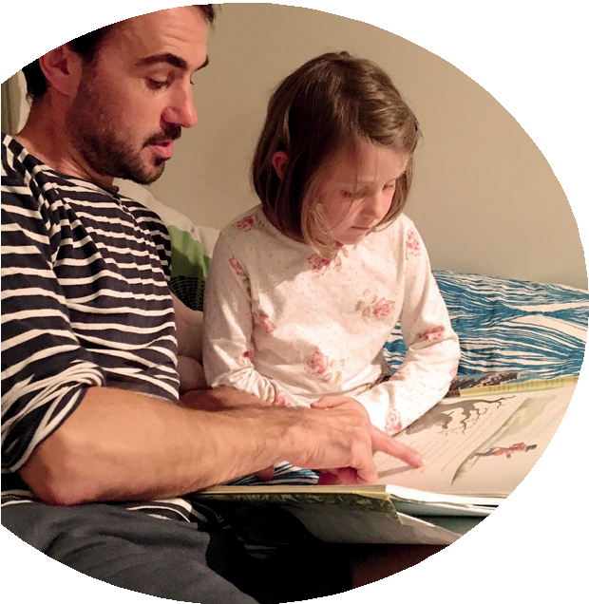
Read stories to your child with feeling! The more you love the story, the more your child will love reading.

Booklet 2 shows you how to help your child practise reading:
- Sets 2 and 3 Speed Sounds
- Pink, Orange, Yellow, Blue and Grey Storybooks.

Your child is learning to read with Read Write Inc. Phonics, a very popular and successful literacy programme. This second booklet shows you how you can get your child off to a quick start.

Your child will learn to read in a very simple way. He or she will learn to:
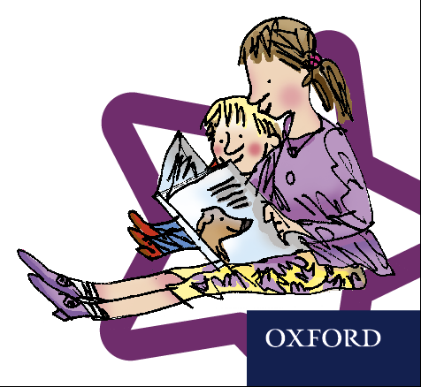
- Read letters by their ‘sounds’

Blend these sounds into words
- Read the words in a story.

www.ruthmiskin.com/parents has many videos to help you help your child.


For more information on Read Write Inc., please talk to the Read Write Inc. manager in your child’s school or visit www.readwriteinc.com.

8

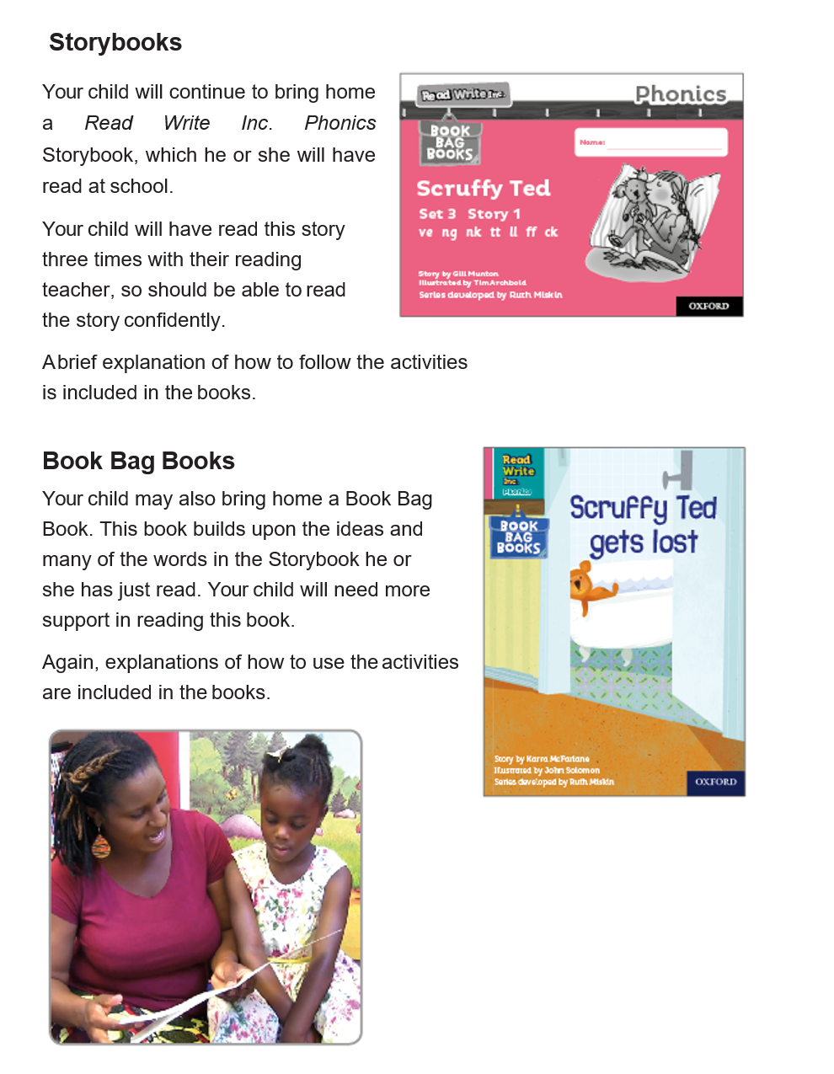
How will my child learn to read?

Your child will already have learnt to read:
- Set 1 Speed Sounds: these are sounds written with one letter:
m a s d t i n p g o c k u b f e l h r j v
y w z x and sounds written with two letters • (your child will call these ‘special friends’): sh th ch
qu ng nk ck
- Words containing these sounds, by sound-blending,
e.g. m–a–t mat, c–a–t cat, g–o–t got, f–i–sh ﬁsh,
s–p–o–t spot, b–e–s–t best, s–p–l–a–sh splash
- Blending Books and Red, Green and Purple Storybooks.

Now, he or she will learn to read:
- Set 2 Speed Sounds: ay ee igh ow oo oo ar or air ir ou oy
- Words containing these sounds
- Pink, Orange and Yellow Storybooks.

Next, he or she will learn to read:
- Set 3 Speed Sounds: ea oi a-e i-e o-e u-e aw are ur er ow ai oa ew ire ear ure
- Words containing these sounds
- Blue and Grey Storybooks.



