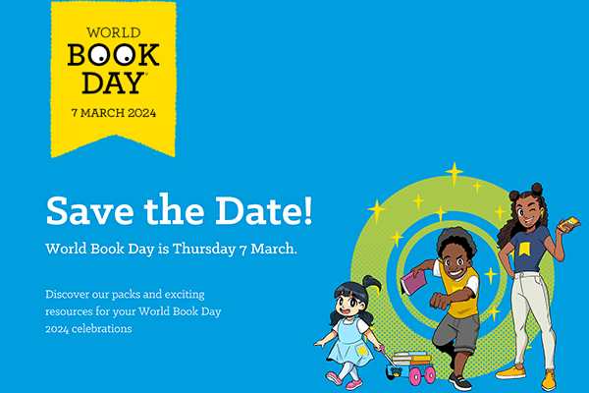

Monday 26th February 2024

Dear Parents/ Carers,

As part of our drive to maintain, promote and engage pupil interest in reading, the school is having a WORLD BOOK day on Thursday 7th March.

Dressing Up
This year we are going to have a whole school theme based around Vocabulary. We invite children to dress up as a word ready for a vocabulary parade! We are hoping this gives a low-cost or free alternative to dressing as a book character with the ongoing cost of living. We are hoping to encourage as many children as possible to make their own costumes. Please see below great word suggestions or ideas such as artistic and blossom so we look forward to seeing every body for this year’s vocabulary parade.
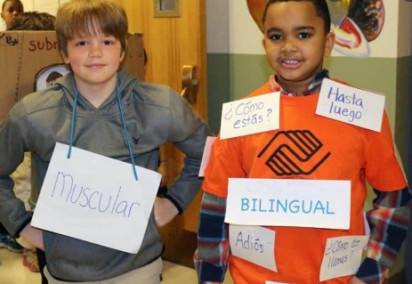
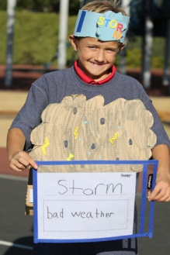
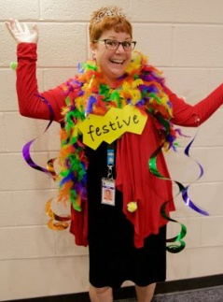
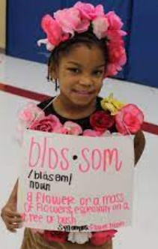
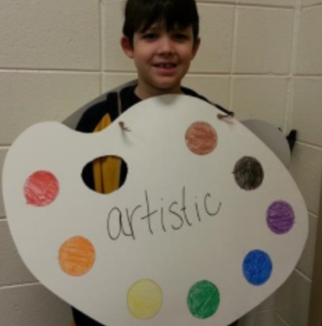

Design A Potato Character
We will be holding a ‘Design a Potato Book Character’ competition this year too. Please use a potato and as much creativity as possible to turn it into a book character of your choice! You may use a range of materials to design your potato including googly eyes, pipe cleaners, paints etc. Your potato must be brought into school on Thursday 5th March to take part in the competition. There will be one winner from each class, prizes to be confirmed.
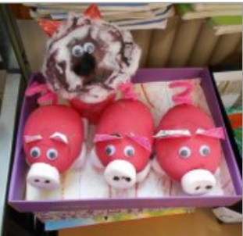
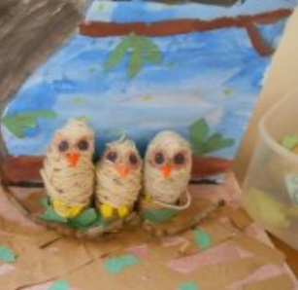
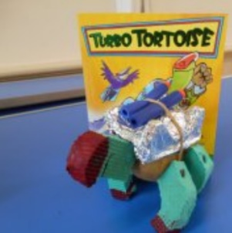
Any questions, please ask your teacher or Mrs Leonard.

Shared Reading
We would like to invite you all to bring in a book to read and share from home. In our classes we will have time to share our books from home together with our parents and enjoy reading. Please make sure your book is named if possible. We would like to invite parents in to join us from 2.45pm on Thursday 7th March.

Book Tokens
We will be giving out the World Book Day Vouchers on Monday 4th March, which can either be used as £1 off at the Book Fair or swapped for a £1 book at a local Book shop in town.

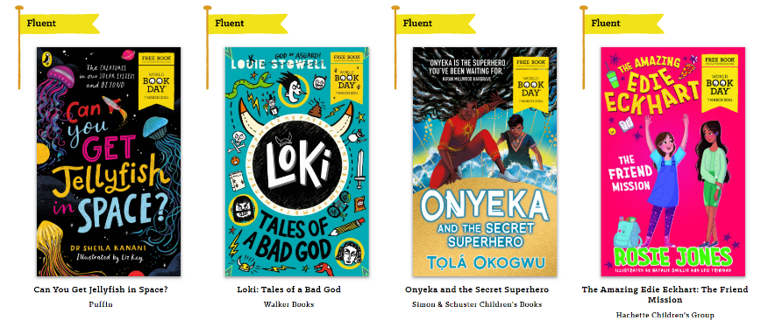
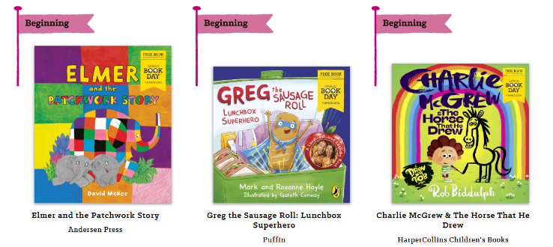
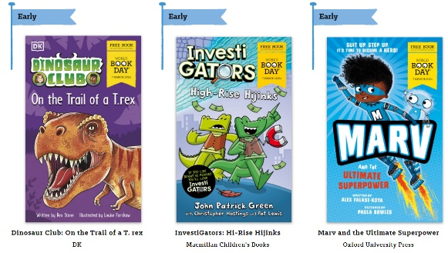
This year’s £1 books are:
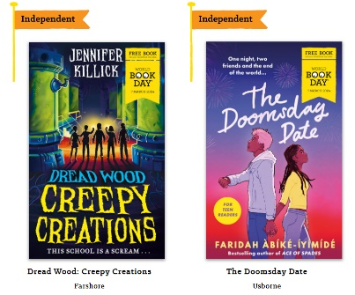

We look forward to seeing your child dressed up for the special day on Thursday 7th March.

Thank you for your co-operation,

Mrs Leonard

