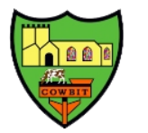
Cowbit St Mary’s Church of England Primary School Newsletter- Term 2
With the end of term 2 nearing, school is full of festive cheer, glitter and a buzz of excitement from the children! Despite the seasonal coughs and colds, it has been a very busy term in school.
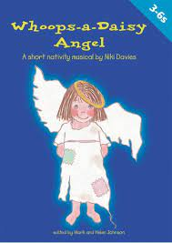
Whoops- a- Daisy Angel
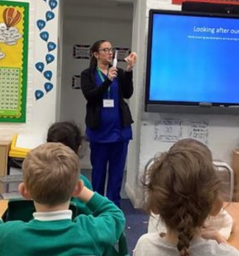
Donaldson class have been busy practising for their nativity play, which takes place on Thursday 14th December. The first performance will be at 10am in the Church and the evening performance will start at 5pm, so we kindly ask that children are returned to school by 4.30pm to get changed. I would like to thank Mrs Smith for all her hard work in preparing for the nativity.

Oral Hygiene
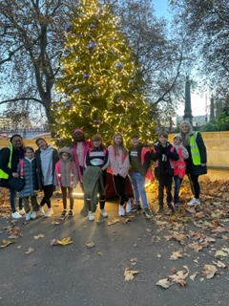
This term we have had the Dentist in to visit Donaldson and Dahl class. They gave us some great tips on how to keep your teeth healthy and kindly donated toothbrushes and toothpaste to all the children to keep up the great work with their oral hygiene.
Residential to London
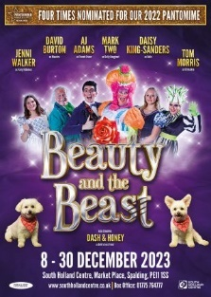
Year 6 had a great time on their residential in London. We were really proud of the Year 6 children who went on the recent London trip. Their behaviour was excellent and we received a lot of compliments from the places we visited about how great the children were. We had a brilliant time on an exceptional trip and enjoyed so many great activities – the best of which was seeing The Lion King! Needless to say, we were all very tired by the end of the weekend!
Beauty and the Beast
On Friday 8th December, the whole school went to see Beauty and the Beast. It was lovely to see the children in their Christmas jumpers, excitedly singing along and joining in with the cast.
Carol Concert
The whole school will be visiting the Church on Wednesday 20th December for our Carol Concert. We will have a performance from the Choir and the children will all take part in some Christmas singing. The concert will start at 1.30pm and families are very welcome to attend. Children may be collected after the concert from school but not from the church please.
Friends of Cowbit
I just wanted to say a huge thank you to our Friends of Cowbit for all the work they have been doing this term, they have raised an amazing £400 at the Christmas Fair. They also have the school disco planned for Friday 15th and a Film Night on Monday 18th, all of which is going towards raising money for a class set of laptops for school so we can deliver our computing curriculum. Without the support of Friends of Cowbit, none of these events would be possible and I know they are always looking for new members to make these events happen.
Staffing
Mrs Relton has also made the difficult decision to leave us at the end of term. Mrs Relton has worked at Cowbit for a number of years and taught many of our school community in her time here. I would like to personally thank Mrs Relton for her service to our children and community as I am sure she will be greatly missed. We wish Mrs Relton all the best in her future endeavours.
Mr Fitzgerald will be joining us until at least Easter as the class teacher in Dahl class. The children met Mr Fitzgerald when he came for interview and had lots of lovely things to say about him. We look forward to welcoming Mr Fitzgerald to our team.
Miss Blake, our teaching assistant in Donaldson, is also leaving having secured herself a permanent position at a school in Wisbech. Miss Blake has been covering Mrs Dilley’s maternity leave, we will be moving Mrs Ham to Donaldson class whilst we recruit a temporary teaching assistant to cover maternity leave.
Mrs Smith will take over as SENCO (Special Educational Needs Co-ordinator) from 1st January.
As we begin our journey to Christmas, we thank God for the blessings of our families and friends. We also bring to mind those less fortunate than ourselves and pray that they may find some joy this Advent season.
And finally, with this being our last newsletter of 2023, may all of us here at Cowbit St Mary’s wish you all a very happy Christmas and a wonderful new year. Thank you for all your continues partnership and support this year, we’re excited to see what adventures 2024 brings! We look forward to welcoming you back on Wednesday 3rd January 2024.
See you next year,
Mrs Leonard

