Cowbit St Mary’s Church of England Academy



Behaviour and Relationships
Policy

Created: October 2025
Approved:
Review: October 2027

Signed by:
_______________________ Headteacher Date: _________________
_______________________ Chair of Governors Date: _________________

At Cowbit St Mary’s Church of England Academy, our motto “Growing together in learning, love and faith” guides everything we do. Our Behaviour and Rewards Policy is rooted in this shared purpose and reflects our commitment to nurturing a community where every child can flourish emotionally, spiritually, and academically.
Our Christian vision reminds us that each child is unique—like a mustard seed—with the potential to grow into something great and wonderful. We believe that positive behaviour is a key part of this growth, and that it must be taught, modelled, and supported with love and consistency.

This policy is designed to:
- Welcome and nurture every member of our community, ensuring that all feel safe, respected, and valued.
- Empower children to thrive through clear expectations, restorative practices, and meaningful rewards.
- Support emotional and mental wellbeing, recognising that behaviour is a form of communication and that children may need guidance and care to make positive choices.
- Promote high standards of behaviour and manners, reflecting our belief in each child’s ability to grow and live life in all its fullness.

Our six core Christian values are the roots of our behaviour policy:
- Respect: We treat others with dignity, honouring our school, environment, and community.
“Love one another. As I have loved you, so you must love one another.” – John 13:34
- Perseverance: We encourage resilience and determination, especially when faced with challenges.
“Let us not become weary in doing good.” – Galatians 6:9
- Forgiveness: We support children in letting go, learning from mistakes, and restoring relationships.
“Forgive and you will be forgiven.” – Luke 6:37
- Responsibility: We help children take ownership of their learning and behaviour.
“For God gave us a spirit of power and love and self-control.” – 2 Timothy 1:7
- Kindness: We foster a culture of compassion and care for everyone and everything.
“So whatever you wish that others would do to you, do also to them.” – Matthew 7:12
- Hope: We encourage optimism and belief in a positive future.
“Plans to give you hope and a future.” – Jeremiah 29:11

By living out these values, we grow together in learning, love, and faith—creating a school where behaviour supports flourishing, and every child is empowered to become a driver of positive change.

Aims
The aim of this policy is to inform a fair and consistent approach to promoting the highest expectations for social and learning behaviour among pupils and staff so that respect and courtesy are the norm and all children feel safe at all times. We believe that children enjoy success, and become more effective learners once their image of themselves is positive and good. At Cowbit St Mary’s Church of England Academy, behaviour management is recognised as a collective responsibility between children, staff, parents, the governing body and other agencies involved with school.

Introduction
It is recognised that, in the majority of cases, children will be as well-behaved and as well-mannered as adults expect them to be and as the prevailing culture dictates. At Cowbit St Mary’s Academy, we set out to ‘catch them being good’ and employ a positive approach to behaviour. We apply ‘loud praise, quiet reprimand’, drawing attention to good behaviour, manners, etc. and discreetly (unless there is a pre-determined reason for publicity) deal with inappropriate behaviour so as to:
• preserve the dignity of the child
• give her/him an accessible route back on track
• prevent other pupils being deprived of more of the adult’s time than is absolutely necessary

Good behaviour both inside and outside the school building is the responsibility of all staff and each one of us must correct anything that is unacceptable. All adults in school must use positive language to reinforce the expected behaviours instead of focusing on the negative. Eg. ‘Walk in the corridor – thank you,‘ rather than ‘Don’t run in the corridor.’ Disapproval must be directed at the behaviour not the child.

The class teacher may wish to discuss persistent behaviour issues with the SENCO. Whilst there will be occasions requiring the intervention of the headteacher, it is important to remember that she is not to be constantly used as a threat; rather, the headteacher is there to encourage and praise, recognising and celebrating achievement and success, both academic and social.

Every class begins the Autumn term by agreeing a Class Charter. The Class Charter is a set of rules that they all agree to adhere to ensuring everyone in the class feels safe and works cooperatively together.

It is also essential that, each September, teachers quickly establish routines and expectations whilst modelling the behaviours we seek to promote.

All members of staff are expected to operate within the framework the policy provides at all times, regardless of their position and experience; consistency is essential in managing behaviour for learning successfully.

Whole school approaches include:

Emotional Coaching
Emotion coaching is a technique designed to help children understand and manage their emotions effectively. This approach promotes emotional intelligence, resilience, and positive behaviour, which are key for a child’s long-term mental health and social skills. Its core principles include: recognising and validating emotions, and offering empathy whilst also placing boundaries in place. We aim to teach children that, while all emotions are valid, not all behaviours are appropriate. Emotion coaching includes setting clear limits on behaviours associated with certain emotions. For example, feeling angry is okay, but hitting is unacceptable. Emotional Coaching teaches children to understand and manage their emotions constructively, improving their ability to handle stress, solve problems, choose appropriate behaviour and build healthy relationships. (Appendix 1)

Loud and frequent praise builds self-esteem
All staff must seek out opportunities to build children’s self-esteem by praising individuals, groups and whole classes. Recognition and approval from teachers and parents motivates children. Praise should be descriptive, genuine and brief. Adults should not overpraise using words like brilliant, fantastic or wonderful but use simple discreet praise eg. you went straight to your table and started your work. In addition to building self-esteem, this style of praise also restates the behaviour you wish to see more of and acts as a cue/reminder to anyone who is not doing as expected. (Appendix 2)

You cannot teach self-esteem. You can esteem the learner, you can provide ‘esteeming’ experiences and you can equip the learner with tools to reframe their experiences more positively. Those are the limits of your influence.

Star of the week
At some point during the year each child in Reception to Year 6 will be ‘Star of the week’. This is an opportunity for the child’s teacher and classmates to praise them specifically. Praise is often linked to our Class Characters or our values, the traits we seek to develop in our children.

Merit Badges
Merit Badges are awarded for green points. Each child is working towards a merit badge of recognition to their positive contributions to school life. Some children who show exceptional effort may achieve consistently above their green points and therefore may go onto to achieve the gold or platinum badge for merit. A green merit badge will be awarded at 600 green points, a gold badge at 750 green poiints and a platinum badge at 1000 green points for those pupils with exemplary behaviour at all times.

Assertiveness
When necessary, adults working in school must adopt an assertive approach which includes using body language and tone of voice to convey our self-belief that children will do as we ask but we do not shout. We stand up tall, establish good eye contact and firmly state what we want the child to do differently and fully expect them to do it. If they do not respond we use the language of choices. (Appendix 3) Shouting at children doesn't work because it triggers their fight-or-flight response, which makes them focus on fear rather than listening and learning, hindering their ability to process the message.

Reflection Time
When children are given time to reflect on an incident, they complete a reflection sheet (Appendix 4). The reflection sheets guide the thought process and discussion for all children and provide consistency in those discussions. The reflection sheets are uploaded to CPOMs and then sent home with children so that parents and carers are aware of what has happened in school and provide a framework for discussion at home.

Behind every behaviour there is a feeling and behind every feeling there is an experience.

Safeguarding pupils with SEN
Each child is a unique individual, and we recognise that some of our children with SEND can experience greater challenges in forming age-appropriate relationships and peer friendships. Each child with SEND is considered in relation to their ability to form secure peer relationships as, without this, they may become isolated or be vulnerable to a greater or lesser extent. Children who are considered vulnerable at different times throughout their schooling, especially those facing transitions, are highlighted to all staff who supervise playtimes. It is the responsibility of every member of staff to report any concerns in relation to children with SEND to the SENDCo/ Headteacher. We understand that all behaviours are a form of communication. With that in mind, we aim to be proactive rather than reactive - teaching children appropriate strategies to help manage their feelings and relationships. We aim to create a positive, predictable and safe environment for the whole school community.

It is understood that children with a special educational need or disability (SEND) need may find it difficult to meet the expectations of behaviour on occasions. We recognise that being ‘fair’ is not about everyone getting the same (equality) but about everyone getting what they need (equity) through appropriate support. With this in mind, we have a graduated approach to behaviour that works alongside the SEND policy and the SEND Code of Practice for the Social, Emotional and Mental Health (SEMH) area of need: please see sections 6.32 and 6.33
https://assets.publishing.service.gov.uk/government/uploads/system/uploads/attachment_data/file/398815/SEND_Code_of_Practice_January_2015.pdf

Preventing bullying and child-on child abuse
The TrackIt Lights system ensures we have a rigorous tracking system. This allows us to identify children with challenging behaviour and those who may be vulnerable to bullying behaviour. If children fall into either category they are highlighted to all teachers and teaching assistants in emails or meetings. This enables close monitoring of potential bullying
behaviour such that it can be stopped swiftly. (See Anti-bullying policy and Behaviour Steps for more information)

It is essential that all staff understand the importance of challenging inappropriate behaviours between children, many of which are listed below, that are abusive in nature. Downplaying certain behaviours, for example dismissing sexual harassment as “just banter”, “just having a laugh”, “part of growing up” or “boys being boys” can lead to a culture of unacceptable behaviours, an unsafe environment for children and in worst case scenarios a culture that normalises abuse leading to children accepting it as normal and not coming forward to report it as outlined in KCSIE 2025.

All staff recognise that ‘child on child abuse’ is most likely to include, but may not be limited to: bullying - including cyberbullying, prejudice-based and discriminatory bullying. Bullying will not be tolerated at our School – see separate Anti-Bullying Policy.

De-escalation and the Language of Choice
Staff are skilled at diffusing high levels of anxiety and angry outbursts. Staff do this by intervening at the earliest opportunity, not taking insults personally, remaining calm and in control, staying quiet to allow take up time, using humour or distraction, offering reassurance or a listening ear and using emotional coaching steps, the language of choices and/or consequences.
On the rare occasion that children do not follow adults’ instructions adults may use the language of choice. There are two ways to use this; one offers real choices and the other delivers the certainty of a consequence. An example of real choices might be: You can complete the work now with support from Miss Dean or by yourself at break time (either way the work will be completed which is the necessary outcome). An example of consequences might be: Do not bounce that ball again or you will be given a yellow for not following my instructions. Both approaches give the child the responsibility and develop self-regulation.

Expectations of behaviour based on School’s aims and values.
At Cowbit St Mary’s, it is expected that every child will:
- Display the school values and follow the Class Charter.
- Listen to and follow instructions and rules set by adults.
- Use technology safely as guided by the adults.
- We use an indoor voice when inside the school building
- We use please and thank you and always use kind words
- We tell the truth straight away
- We stop and listen at the raised hand signal
- We wear the correct uniform
- We respect others and school property in school and when outside at play and lunch times
- We are enthusiastic about our learning and try our best

At the start of each academic year, the children and their new class teacher/s will agree the
behaviour that is expected. It is important to do this at the start of every academic year to reinforce expectations; these will form part of the Class Charter which is displayed in the classroom. This will be referred to regularly and revised in light of repeated instances of unwelcome behaviour.

Unwelcome Behaviour
It is unacceptable for anyone to:
• Disturb the learning of others
• Be disrespectful or speaking inappropriately
• Use rude language or swear, including online
• Use aggressive and physical behaviours towards others
• Be dishonest
• Bully others, including online
• Leave the classroom without permission
• Not following adult instructions or requests
• Damage equipment or purposely use it in the wrong way

At Cowbit St Mary’s Church of England Academy, we use Track-It Lights as a behaviour management tool. Track-It Lights records both positive and negative behaviours and allows the school to track patterns of behaviour across all classes and year groups. It is the responsibility of the adult who has witnessed that behaviour to record any behaviour on Track-It Light.

The Four Stages of Behaviour
This table outlines the four key stages of behaviour within our school. It provides examples of behaviours and the resulting actions and consequences followed at Cowbit St Mary’s Church of England Primary School.
Parents/Carers should be aware that these examples are not exhaustive.
Our approach to behaviour has been inspired by The Toolkit for Regulation created by
Lincolnshire’s Behaviour Outreach Support Service (BOSS).

Behaviour | Examples | Action
Green Behaviour | Children feel happy, safe and ready to learn. This is where we aim for all our children to be. | Expected behaviours recognised and rewarded by:  Showing work to the headteacher  Trophies and Special Awards e.g. writer of the week, termly attendance  Child, group or class chosen as a role model for others  Written praise e.g. a positive comment on work  Verbal praise  Peer group praise e.g. a clap, praise action etc.  Smiles and thumbs up  Stickers  Earn points on Track-It Lights for demonstrating positive behaviours.  Track-It Lights certificates earned through positive behaviours – Bronze, Silver, Gold, Platinum, Diamond  Treasure Chest Prizes  Weekly: Star of the Week linked to our Christian Values (1 per class)  This is managed by classroom-based staff.
Amber Behaviour | Not following Class Charter  • Distracting others (preventing the learning of others).  • Unfocussed and off task.  • Purposeful intent to cause frustration in others  • Not telling the truth  • Misuse of equipment without intent of injury or damage.  • Low level disruptive behaviour  • Refusing to complete work | • Positive reinforcement given to those following expectations.  • Positive and clear reminders of expectations are provided to the child, for example, ‘Look this way. Focus on your work.’  • Verbal warnings  • Move pupil to another area of the classroom  • Ascertain if the child needs any support.  • Referral to the Class Charter and School Values  Multiple amber behaviours occur, this will be classed as yellow behaviour.  This is managed by classroom-based staff
Yellow Behaviour | Not displaying School Values  • Repeated occurrences of amber behaviours  • Causing persistent disruption over time to learning (for themselves and others)  • Damage to school equipment or petty theft.  • Indirect (not aimed at anyone) use of inappropriate language.  • Inappropriate physical contact (persistent pushing and shoving during a game-type situation, tripping someone up intentionally)  • Impulsive physical harm (not intended to harm).  • Intentional unkindness towards others.  • Refusal to co-operate  • Leaving class without permission | • Verbal warning given.  • Time removed from break/lunch times to reflect and reset- 5 minutes from break OR 20 minutes from lunch.  • Natural consequences, for example, work to be completed, pick up items that have been thrown etc.  • Yellow stages will be logged on the Track-It Lights system-parents/carers will be informed.  • Monitor the child and provide strategies/support.  • Supportive interventions may be put in place.  • Consider withdrawal from class.  This is managed by classroom-based staff and SENCO.  A reflection form will be completed by the child
Red Behaviour | •Escalated (out of control) behaviour.  •Regular yellow behaviours  • Persistent, intentional unkindness towards targeted individuals (bullying).  • Direct inappropriate language including homophobic and racist language  • Intentional physical harm to others including adults.  • Absconding.  • Theft of significant items.  • Having or using a weapon  • Serious damage to school property  • Fighting | In this stage, the SENCo will understand and support the class teacher to manage the behaviour with strategies.  • Trained Team Teach staff may be called on.  • Consider specific zones to play in  • Reset time with the child to discuss their actions, their next steps and reminder of the school values and expectations.  • Meeting with parents/carers, class teacher, and/or Leadership Team.  • Consider withdrawal from class- internal isolation.  If Red Behaviours continue over time:  • Pastoral Support Programme (PSP) may begin.  • Consider suspension from school.  • Permanent exclusion  The Headteacher will be informed and manage this behaviour.  A reflection form will be completed by the child
Discipline Procedures
1. Clear 1st verbal warning (names are not to be put on the board)
2. Child’s behaviour is recorded as an amber behaviour on Track-It Lights.
3. Child’s behaviour is recorded as a yellow behaviour on Track-It Lights, child misses 5 minutes from next break, if appropriate and a reflection form is completed with their class teacher or an appropriate adult in this time.
4. Child’s behaviour is recorded as a red behaviour on Track-It Lights, Incident Form filled in on TrackIt Lights by the adults– saves on CPOMs. Parents called or spoken to and a written reflection form is to be completed by the child, shared with parents and given to Mrs Leonard.
5. Three red behaviour Track-It Lights within one short term (6-7 weeks) requires teacher to complete Restorative Discussion with child once they are ready to talk. Parents will be invited in as part of this process.

Behaviour Conference
3 red Track-It Lights, in first small term, would trigger a behaviour conference – detailed below:
1st conference, the class teacher to lead conference with parents, teacher and child (where appropriate)
If red behaviours continue, this will trigger a second behaviour conference with the parents, teacher, Headteacher and child (where appropriate)
A PSP (Pastoral Support Plan) may be considered at any stage when a child is on red to take into account the behaviours displayed.

Role of staff and volunteers

• To have and show respect for every child
• To view behaviour as a form of communication
• To form positive relationships to enable children to feel secure in school.
• To maintain clear boundaries and expectations
• To record incidents on the school’s recording system Track-It Lights (collaborated with
CPOMS)
• To work collaboratively to reinforce the strategies agreed in line with this policy
• To ensure all reflection forms have been completed and shared with SLT

The class teacher should contact a parent if there are worries about the behaviour of a child and there is a persistent pattern of amber behaviour being displayed. The class teacher should not wait until the behaviour becomes an issue (yellow behaviour). They should discuss their concerns honestly and openly with parents/carers and agree a plan of action in private. Such a conversation should be recorded on CPOMS. Class teachers should comment about a child’s behaviour in the Annual Academic Report to Parents.

Role of the Headteacher and Leadership Team

• It is the responsibility of the Leadership Team to monitor the implementation of the
Behaviour and Rewards Policy throughout the school and to report to governors on the
effectiveness of the policy.
• The headteacher has the responsibility for giving fixed-term suspensions to individual
children for serious acts of misbehaviour. For repeated or very serious acts of anti-social
behaviour, the headteacher may permanently exclude a child. Both these actions are only
taken after the school has sought advice from the Pupil Reintegration Team and the Local
Authority and Chair of Governors has been notified.

Please see Lincolnshire Ladder of Behavioural Intervention 2022

Role of the Local Governing Body
The Governing Body has the responsibility for reviewing the effectiveness of this policy and for its regular review.

Date of Review: Ongoing. Formally reviewed:

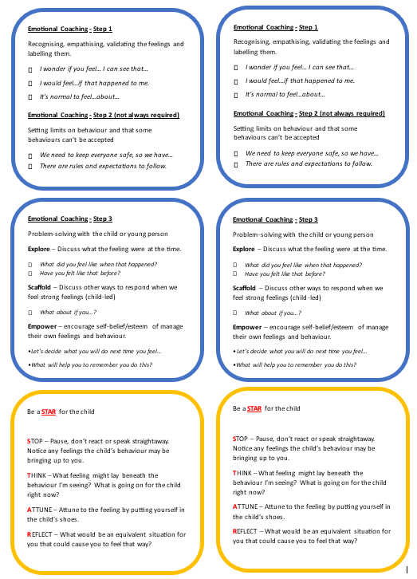
Appendix 1- often used when we see dysregulation

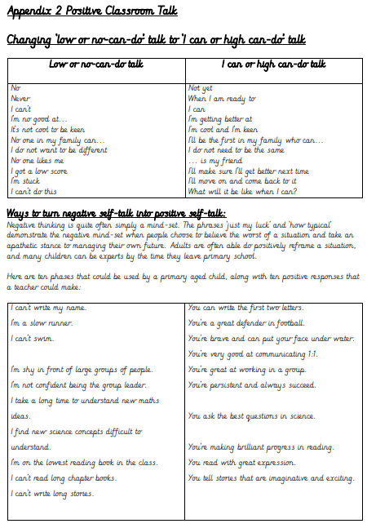
Appendix 2
Appendix 3- often used when a child is in fight or flight mode

The Language of Choice – 3 Steps to Success

Step 1 – Statement of reality (tell them what you see)

Sam, you’re climbing over the fence.

Never ask a child why they are doing what they are doing.

It is confrontational and you don’t actually need to know why they are doing it – they just
need to stop it!

After hearing you use a statement of reality, many children will quickly do something to
change the behaviour without having to move further down the script. Remember: you
need to give them take-up time to do this rather than stand over them which again can be
confrontational. Remember to praise them if they change their behaviour.

Should they not change their behaviour, the next part of your script is:

Step 2 – Describe the behaviour you want to see, ending the statement with a
thank you

Sam, you need to collect the ball by using the gate – thank you.

Rather than starting or ending your statement with please, use a thank you instead. A
thank you carries more of an expectation that they will do as you have asked them to do.

Remember to use these scripts with a smile in your voice and on your face as you are more
likely to get positive results.

Step 3 – Statement of choice (Real or consequence)

Real choices

Offering real choices means the child has a degree of control over how the necessary
outcome is achieved. The teacher would be happy with either choice as both result in the
same outcome. e.g. You can choose to leave the classroom and work with Miss Dean or Mrs
Ross – who would you prefer to work with?

The choice of a consequence

The language of choices and consequences gives the child the responsibility for the
consequences that you will carry out (and you must deliver consequences or the child will
learn that you do not follow threats through).

Sam, if you choose to continue to climb over the fence then you’ll get a yellow
for not following my instructions. It’s your choice.

Although it’s easier said than done, you should remain calm and assertive rather than
aggressive when using these scripts. If you lose your cool, then the child will pick up on
your tone and may well be aggressive back which will make the situation worse.

Most importantly, if after using the language of choice the child chooses to do the right
thing, then you must praise them for making the right choice. This means that the child
learns that it’s good to do the right thing and that you are pleased that they have made a
good choice. Every child loves to be praised on the inside, even though they might not
show it on the outside.

Well done Sam, you made the right choice.

Ignore them stomping around or grumbling as they do the right thing – the most important
thing is that they have made the right choice!

Should the child choose not to do as you have asked, then it’s absolutely simple: you
follow through with the consequences you stated.

Don’t cave in to their protests as you carry out the consequences – if you are consistent, the
methods outlined will work. You could repeatedly say e.g. ’In our school, everyone has to
follow adult instructions’ which reminds them of the rule which never changes; this implies
the system is there and is fair, rather than personal and ‘against’ them.

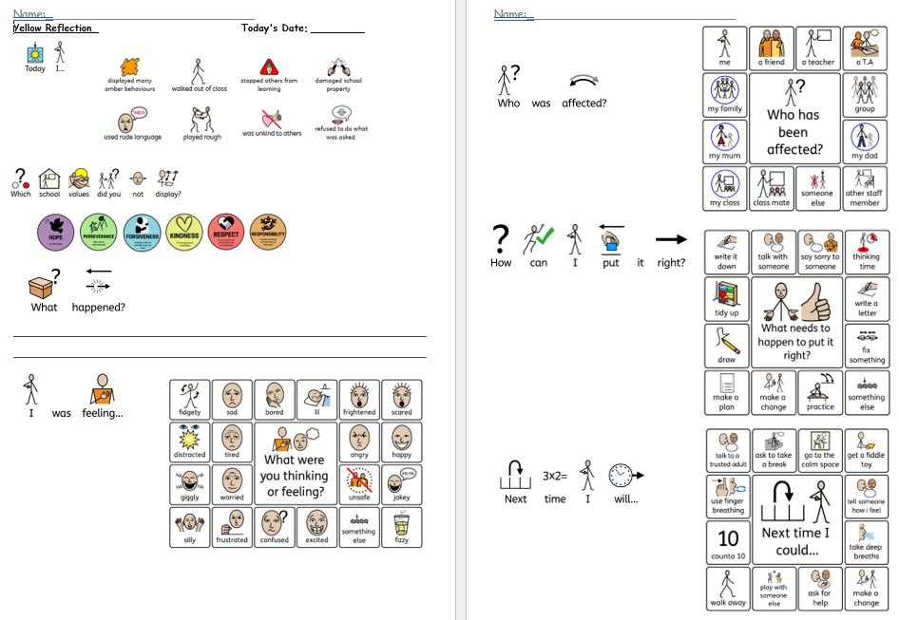
Appendix 4

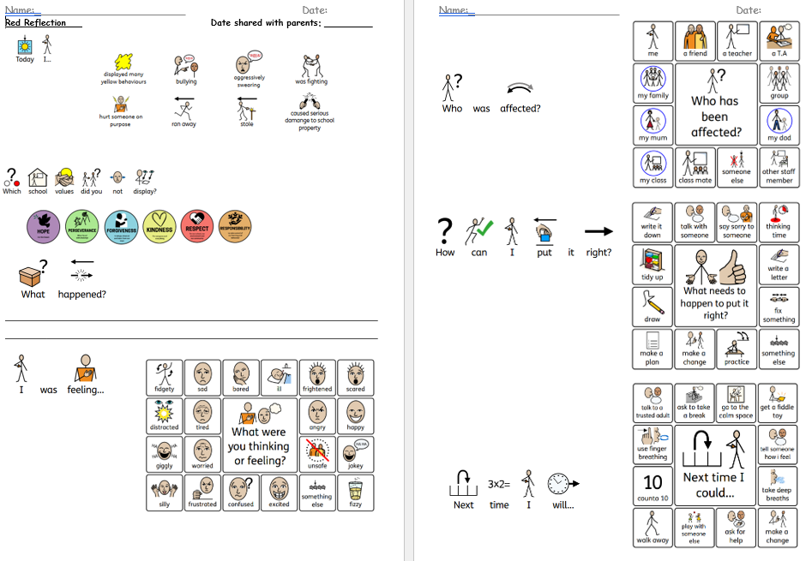
To be sent home on yellow paper
To be sent home on red paper

