Cowbit St Mary’s Church of England Academy

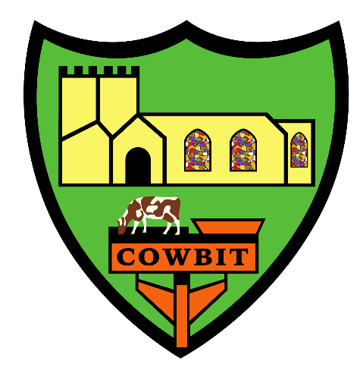

Equality Information and Objectives Plan

Date created

Equality Objectives 2025-2028
The Equality Act 2010 requires schools to publish specific and measurable equality objectives as based on our analysis of data and other evidence. Our equality objectives focus on those areas we have agreed to take action to improve equality and tackle disadvantages. We will regularly review the progress we are making to meet our equality objectives.
Please refer to the KAT Equality and Objectives Policy for further information.
 | Aim | Action to be taken | Staff responsible | Timescale | Resources | Impact
1 | To develop pupils’ awareness of British Values. | British Values Display created and regularly updated to make links between these values and the events and curriculum work taking place in school. | Headteacher  Class Teachers | June 2024 - Ongoing | LCC Links e.g. Magistrate’s Court  School funds to visit places of faith and worship. | In February 2025, we were visited by Ofsted which said, ‘Personal development lessons are well planned and help pupils prepare for life beyond school. Pupils develop a strong understanding of fundamental British Values. They learn how to develop healthy relationships and demonstrate respect and tolerance.’
1 | To develop pupils’ awareness of British Values. | Establish Pupil Parliament to organise and vote on school events. | Headteacher | September 2024-ongoing | N/A | Pupil Parliament was established in Summer 2025, this needs to be renewed for 25/26 with Year 2 pupils given the opportunity to apply and a regular meeting schedule set up.
1 | To develop pupils’ awareness of British Values. | Building in of British Value links within the curriculum. | Headteacher | September 2024-July 2026 | N/A | Our current curriculum offer has opportunities for British Values to be explored e.g. In Year ½ they look at Florence Nightingale (Individual Liberty, Mutual Respect), Mary Seacole (Tolerance) and Edith Cavell (Rule of Law, Mutual Respect) and how each of these demonstrate the core British Values.
1 | To develop pupils’ awareness of British Values. | Directed progressive lessons on British Values delivered across the school to progressively develop pupils’ understanding. | Headteacher  Class Teachers | September 2024- Ongoing | N/A
2 | To develop pupils’ awareness of protected characteristics and understanding of equal opportunities-  - Age  - Disability  - Marriage or civil partnership  - Race  - Religion or belief  - Sex  Although we appreciate there are 9 protected characteristics, we choose to focus on the above 6. | To ensure staff are familiar with the wording of protected characteristics when speaking to children to be respectful of our local communities wishes e.g. expecting rather pregnancy | All staff | June 2024- ongoing |  | We promote the 6 protected characteristics across the school and wording represents our community preferred terminology. Staff are all aware of this and are careful when selecting texts or teaching RSHE higher up the school.
2 |  | To identify opportunities to enhance pupils’ awareness of protected characteristics through books and curriculum links. | Headteacher  SENCo | September 2024 - Ongoing | Community visitors | The school have purchased a range of texts to support Protected Characteristics, we have some on display in the corridor and each class have a set. These have been identified and woven into our Reading Spine.
3 | To raise pupils’ awareness of racial and religious diversity. | To plan a curriculum which provides pupils’ opportunities to visit places of worship and interact with those of different faiths. | Headteacher  Class Teachers | June 2024- ongoing | School funds to visit places of faith and worship. | In 24-25 Year ¾ went on a school trip to the Temple and Gurdwara in Peterborough. All pupils at Cowbit regularly visit the Church next door but KS1 pupils did this specifically for R.E. in 24/25.
3 |  | To celebrate and take part in key events including Black History Month and Race Awareness Week. | Headteacher | September 2024 - Ongoing | N/A
3 |  | To build a diverse reading spine that celebrates a variety of authors’ work including those with differences in race, culture and background. | Headteacher | June 2024- June 2025 | Funds budgeted to the purchase of diverse books and authors
3 |  | Make links between the school and local church, local community workers and members of the local area. | Headteacher | June 2024-September 2026 |  | In 24/25, school worked to build partnerships with the local community. We had Rev Sweeting in weekly for collective worship and the Cowbit Crafters came in to support us with our DT in Y1/2. We also made links with Trevor Tyrell our local farmer. We also celebrated British Sign Language week with a visit in from Venetia who delivered an assembly on BSL and taught the children BSL.
4 | To raise the  attainment and  progress of pupils  with English as an  additional  language. | Additional targeted support for  pupils to develop their phonic  knowledge | More EAL pupils allow the phonics screening check by the end of KS1. | June 2024- ongoing | RWI Resources  RWI Intervention | In 24/25, 100% of pupils passed the phonics screening check and 100% by the end of year 2 cumulatively regardless of background.
4 |  | Develop use of comprehension  to support pupils in  understanding nuances of  English language. | EAL pupils make improved progress with their understanding. | June 2024- ongoing | Active English  Active Spelling
4 |  | Ensure correct modelling of grammar and standard use of English. | EAL pupils make improved progress with their spoken language. | June 2024- ongoing | Active English  Active Spelling

