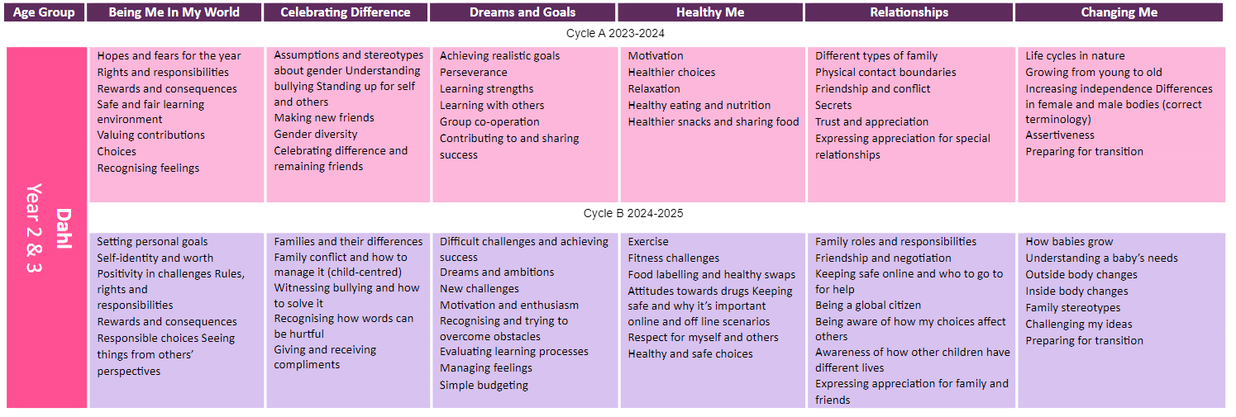
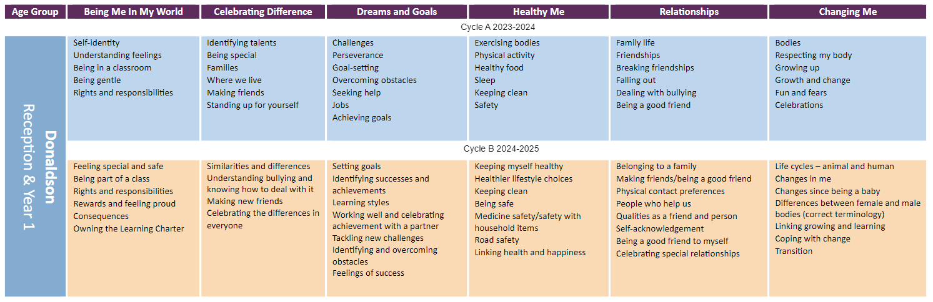

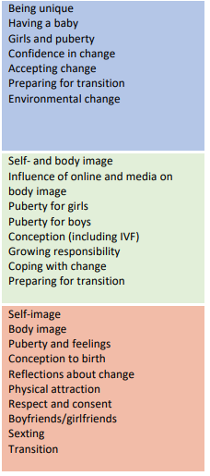
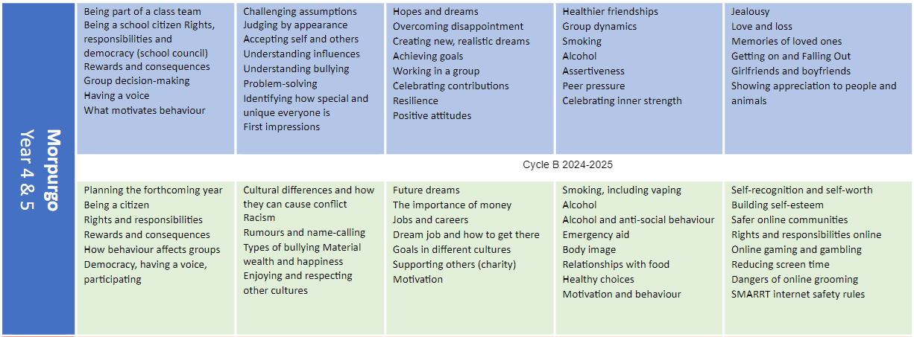
Morpurgo
Year 4, 5 & 6
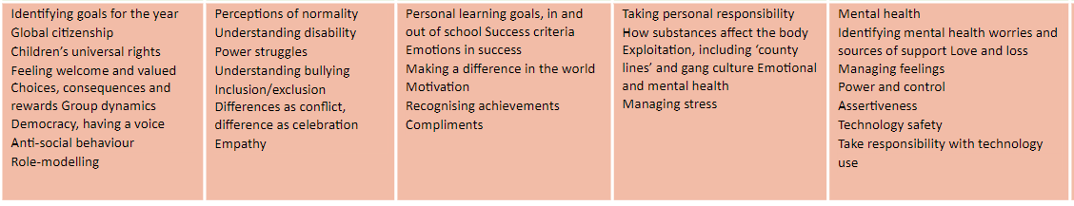
Changing Me unit to be taught in Year groups from Year 4/5/6 every year to ensure content is age appropriate.

