

The Cowbit St Mary’s Church of England Academy Newsletter
Dear Parents and Carers,
As we come to the end of another busy term, we are reminded of the many changes and new experiences that each season brings to our school community, we see this reflected in the growth, learning and joy by our children each day. “To every thing there is a season, and a time to every purpose under the heaven” Ecclesiastes 3:1.
Staff News
Welcome
We are delighted to welcome Miss Warboys who is our new Midday Supervisor.
Clubs next term
Monday – Arts and Crafts with Mrs Cornwell
Wednesday – Dodgeball with Elite
Thursday - Disney Club with Ms Croft
Friday – Multi-sports with Elite
All clubs run straight from school until 4.20pm. Please sign up on MCAS. There are 20 spaces available for each club. You should get a notification on MCAS when these are available to book.
Mrs Links will continue to run a year 6 Quiz club in preparation for SATS.
World Book Day
To celebrate World Book Day this year on Thursday 5th March, we are inviting all children to come to school dressed as a WORD! Children should choose an interesting word and create a costume that represents its meaning.
Some simple ideas could be to dress as the word 'blue' or 'sparkly'
We would especially love to see children using ambitious vocabulary.
Here are some examples of Tier 2 words your child might choose:
• Courageous • Enormous • Dazzling • Furious • Delighted • Mysterious • Ancient • Swift • Proud
• Tremendous • Exhausted • Brilliant • Curious • Terrified • Glorious
Children can be as creative as they like in showing the meaning of their chosen word through their costume.
There will be a prize for the best-dressed word in each year group, so we are looking forward to seeing lots of imaginative ideas! But please make sure the outfits are sensible and safe for school, for example no high heels.
We can’t wait to celebrate reading and vocabulary in a fun and creative way.
Talk on Islam
Our Student Teacher, whose faith is Muslim, gave a talk to Ash and Elm Class, about Islam. They had lots of good questions such as Why do your take your shoes off in the Mosque?, Why does your God have 99 names? How are Muslims different to Christians? Why do men and women pray separately? What is it like in a Mosque? and were very interested by the answers.

Junior Online Safety Officers
Our new Junior Online Safety Officers, Ava, Amelia and Eadie have had their first meeting and will be running some events for the children across the school.
Swimming
Years 3, 4,5 and 6 will continue with their swimming lessons this term on Monday afternoons. Pupils will be accompanied and supervised by staff members from our school.
Children should bring their swimming kit and towel to school, and they will get changed at the pool. Swimming kits should consist of a one-piece costume, bikinis are not suitable. Trunks should be short, not knee length. Swimming hats are compulsory. We ask for a £3.50 voluntary contribution per week to cover costs for transportation and a lifeguard.
Parents Evening
Parents Evening is on 23rd February from 3.30pm-5.30pm and 24th February 4pm-6pm. Please make appointments on MCAS.
Friends of Cowbit
As you may have noticed we were unable to run a Valentines Disco this term due to having limited volunteers on Friends of Cowbit which is making it increasingly harder for events to happen. Please consider helping, we have had no new volunteers come forward. As mentioned in previous messages, it doesn’t need to be a big contribution but every little helps as there are only a couple of people organising these events for parents and children and if no one helps this will affect more events in the future.
Friends of Cowbit are currently running a £20.26 challenge where they have asked pupils to challenge themselves and see if they raise the sum of £20.26 which will go towards trips.
On 17th March Ash Class will be going on a trip to Lincolnshire Wildlife Park. They raised so much on their sponsored walk that Friends of Cowbit were able to subsidise the trip by £12 for each child so parents only have £8 to pay instead of £20!
On 13th March Maple Class will be going on a trip to Sleaford Art Hub. Their trip was also subsidised according to the money they raised for their sponsored walk and Friends of Cowbit subsidised their trip by £3 per child so they only have to pay £15 instead of £18.
Maple Class
Maple Class had a visit from Lincolnshire Stay Safe Partnership where they looked at positive relationships and learned about racism.
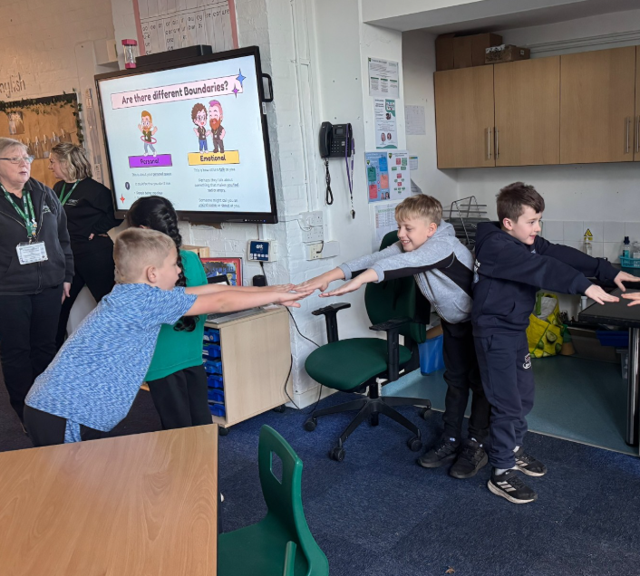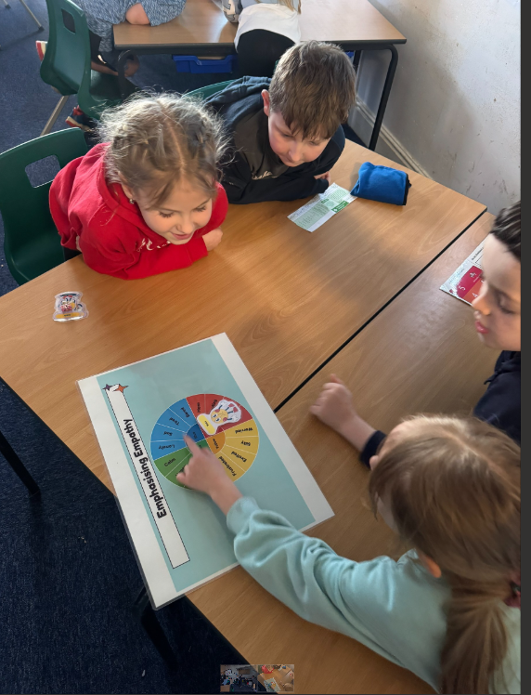

Oak Class
London Residential Trip
Six pupils from Oak Class attended the trip to London last week, they had a great time visiting The Tower of London, The Imperial War Museum, The Science Museum and watched Hercules the Musical. We hope they came home with lots to tell you.
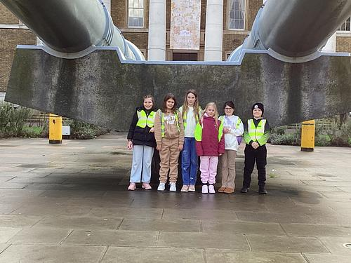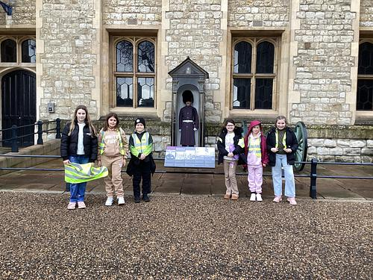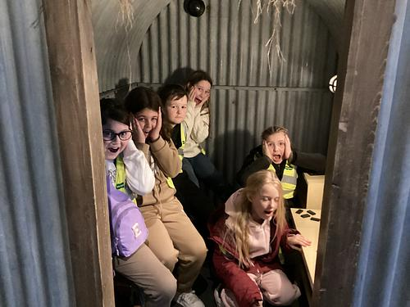
Leavers Hoodies
Year 6 children have been presented with their leavers hoodies in assembly today. They may wear these as part of their school uniform if they wish.
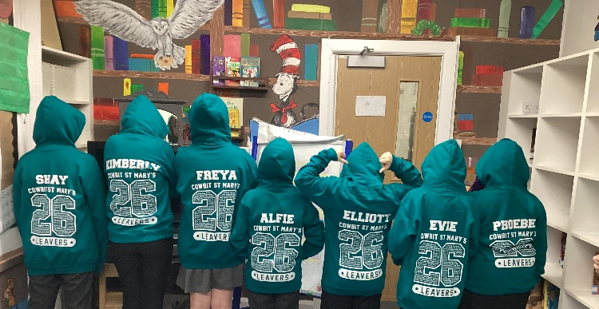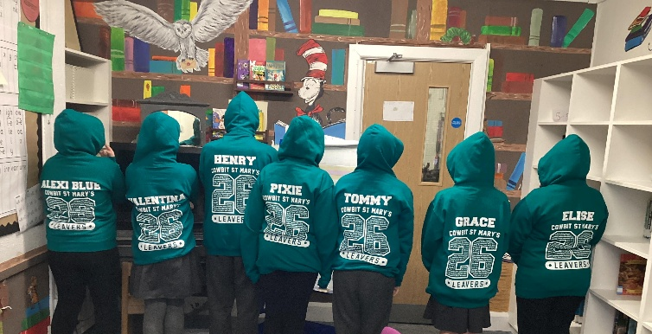
Breakfast Club
Breakfast Club is open every day at 7.30am. A charge of £3.50 is made which includes breakfast and entertainment. There is a variety of activities each week including arts and crafts, Lego, games and TT Rockstars. Breakfast Club now needs to be booked and paid for in advance. There is a discount if you attend all week as the price will be reduced to £15 for the full week. There is also a sibling discount, where if two or more children from the same family attend, the cost will be reduced to £2.50 per child.
Class Dojo and MCAS
Every family has been invited to Class Dojo and MCAS. Please join if you haven’t already. Class Dojo is our message system to parents and on it you will find reminders and things happening in school. It is also a quick way for you to contact us if you ever have a question or concern. MCAS is where you will need to pay for trips and book into clubs and parents evenings, please make sure you checked that your permissions and details are up to date, especially the permissions which relate to Trust wide publications. We have started using MCAS more now for communications as well to make sure everyone is receiving information from us.
Attendance
Late Arrival at School
The school gates open at 8.40am and lessons start at 8.50am. If your child is arriving after 8.50am they are missing learning time. If you arrive after 9.20am you will get an unauthorised mark which goes down as a half day absence. These unauthorised late marks count as 1 absence towards the 10 unauthorised absences in 10 weeks so you could end up getting a fine for unauthorised absence just for being late on a regular basis.
Appointments
A lot of school is being missed due to appointments. Please try and make appointments out of school time. If this is unavoidable, if you can bring your child into school for registration in the morning or take them after lunch in the afternoon, this will not affect their attendance as registers will have been taken. As this is happening a lot, we now need to see proof of appointment in order to authorise medical, dental or opticians appointments, if we don’t it will go down as an unauthorised absence.
Minor Illnesses
If we think your child is too ill to be in school, we will ring you and ask you to either bring some medicine for them or ask you to pick them up. Too many children are staying off school with a cold, or a sore throat or other minor reasons when they could be in school learning. Quite often when the children return to school, we are told they were fine by lunchtime. Once distracted they usually feel better! Missed school means missed learning opportunities.
First Day Calling
In order to comply with safeguarding procedures and follow our attendance policy, we will continue to operate a ‘first day call’ when children are absent. If your child is absent from school, we would appreciate if you could telephone and let us know before 9.30am. If your child continues to be off, please call every day or expect a call from us.
Home Visits
If any child is absent for a period of 3 days or longer, we will complete an unannounced welfare check where we conduct a home visit to check everybody is safe and well. If there is no answer, a calling card will be left asking you to contact school as soon as possible. We will still complete a home visit if you have called, in line with new expectations.
Attendance Penalty Notice
The current Government guidelines now make it clear that Headteachers are instructed that they may not grant any leave of absence unless there are exceptional circumstances. As a result. Any holiday requests will be unauthorised unless exceptional circumstances can be evidenced. If a pupil has 10 unauthorised sessions (5 days – 10 sessions) accumulated within a 10 week period, a Penalty Notice may be issued. The Penalty Notice comes directly from Lincolnshire County Council, and the offence is £160 per child, per parent but if paid within 21 days this will reduce to £80 per parent per child for the first offence. Everyone has been given a formal warning letter which is valid for 2 years. It is a legal requirement for us to make sure everyone receives a letter and is aware of the rules.
Please note this is for unauthorised absence. If your child is ill, please call in as usual and let us know. We understand that everyone gets ill, the above guidelines are for absences such as holidays or days off school that are not for medical reasons. If you need to get a dentist or doctor’s appointment for your child, please try and make these out of school time but if it can’t please let us know, you may be asked for proof of appointment if these are happening regularly.
School Attendance Letters
The expected level of attendance- 95% and above. This term you will receive a letter about your child’s attendance if they have missed more than 5 days of school since September which is anyone under 95%. If their attendance does not improve in the next term, you will be invited in for a School Attendance Tracking meeting where we will try and help with any issues and work with you to improve attendance. If your child has missed more than 7 days of school since September you will receive a letter inviting you to a School Attendance Tracking Meeting, aimed at working together to improve attendance.

Attendance Raffle
As part of our action plan to improve school attendance, if your child has been in school every day of the week, they will receive a raffle ticket to enter our termly draw. The more raffle tickets they have, the higher their chances of winning our attendance prize. We have a prize for a child in Key Stage One and a prize for a child in Key Stage Two. This term’s winners are Tommy and Ruben.
Dates for Your Diary
- 23rd February 2026 – Back to school.
- 23rd February and 24th February –Parents evening
- 2nd March – Ash Class – Chicks arrived
- 13th March – Maple Class Trip
- 17th March – Ash Class Trip
- 20th March – Comic Relief
- 11th-14th May - SATS Week - Year 6
- 22nd May – Non uniform in exchange for prize for the colour tombola – more information to follow.
- 3rd June – Sports Day (Weather permitting)
- 8th June - Phonics Testing Week
- 1st-12th June – Multiplication check for year 4
- 11th July – Summer Fair
On behalf of everyone at Cowbit St Mary’s Church of England Academy, we wish you and your families a fun-filled half term, and hoping everyone comes back refreshed and ready to work.
The Cowbit St Mary’s Church of England Academy

