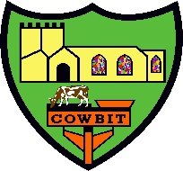

Cowbit St Mary’s CofE School
Relationships, Sex and Health Education Policy

This policy will be monitored and reviewed by the full governing body.
Reviewed by: | Date of review: | Changes made:
Created: August 2023
Approved: September 2023
Next Review Date: September 2025

Signed by:
_______________________ Headteacher Date: _________________
_______________________ Chair of Governors Date: _________________


RSHE Policy for The Cowbit St Mary’s (Endowed) Church of England Primary School
A Church School in the Diocese of Lincoln.
School vision statement:
We are a small, inclusive Church of England Primary School that welcomes everyone and encourages all voices to be heard. Through challenge and support, we strive towards each person becoming the best person God intended them to be, happily flourishing as human beings. We empower our whole school community to be hopeful about the future and to be drivers of positive change.

This policy has been developed in consultation with all stakeholders, including governors, staff, pupils and parents/carers.
1. A Definition of Relationships, Sex and Health Education for Church Schools
All Church of England and Methodist schools within the Diocese of Lincoln are statutorily required
to teach Relationships Education, Relationships and Sex Education and Health Education. Within the
context of Christian beliefs about human dignity (e.g. Genesis 1:26-27) and the need to love your
neighbour as you love yourself (e.g. Mark 12:30-31), RSHE enables pupils to flourish and gain every
opportunity to live fulfilled lives.

RSHE is about the emotional, social and physical aspects of growing up, healthy relationships, sex,
human sexuality and sexual health. It is also about the spiritual and moral aspects of relationships
within a context of a Christian vision for the purpose of life. Through RSHE in church schools, pupils
will have the chance to learn about how to ensure that they treat themselves and others; at all times and in all contexts, with dignity and respect.

Relationships Education is learning about how to:
• be appreciative of existing relationships
• to form new healthy relationships
• to enjoy strong positive, non-exploitative, caring relationships online and in person.

This will particularly reference family relationships including marriage, friendships and relationships with peers and adults.

Sex Education in primary schools is not mandatory; however, the National Curriculum for Science in primary schools includes content about human body parts, growth, puberty and reproduction. Parents/guardians do not have the right to withdraw from this aspect of the curriculum. The DfE Guidance 2019 (p.23) recommends that all primary schools ‘have a sex education programme tailored to the age and the physical and emotional maturity of the pupils. At Cowbit St Mary’s Church of England Primary School we have decided that it is important to include a sex education programme tailored to the age and the physical and emotional maturity of our pupils in order to protect and prepare the children in our school. We will ensure that both boys and girls are prepared for the changes that adolescence brings and – drawing on knowledge of the human life cycle set out in the national curriculum for science - how a baby is conceived and born.

2. Statutory Requirements
As a local authority maintained church school, we are statutorily required to provide Relationships Education to all pupils under section 34 of the Children and Social Work Act 2017. We are not required to provide Sex Education, but we are required to teach elements of sex education contained within the Primary Science curriculum.
In teaching RSHE, we have regard to the guidance issued by the secretary of state as outlined in section 403 of the Education Act 1996.
At Cowbit St Mary’s Church of England Primary School, we teach RSHE as set out in this policy.
3. RSHE Curriculum
Our RSHE curriculum has been developed in consultation with stakeholders, including governors,
staff, pupils and parents/carers and takes into account the context of the school and its pupils.

Jigsaw covers all areas of PSHE recommended by the government for the primary phase including statutory Relationships and Health Education in a consistent and well-structured way. The table below gives the learning theme of each of the six Puzzles (units) and these are taught across the school; the learning deepens and broadens every year.
Term | Puzzle (Unit) | Content
Autumn 1: | Being Me in My World | Includes understanding my own identity and how I fit well in the class, school and global community. Jigsaw Charter established.
Autumn 2: | Celebrating Difference | Includes anti-bullying (cyber and homophobic bullying included) and understanding
Spring 1: | Dreams and Goals | Includes goal-setting, aspirations, who do I want to become and what would I like to do for work and to contribute to society
Spring 2: | Healthy Me | Includes drugs and alcohol education, self-esteem and confidence as well as healthy lifestyle choices, sleep, nutrition, rest and exercise
Summer 1: | Relationships | Includes understanding friendship, family and other relationships, conflict resolution and communication skills, bereavement and loss
Summer 2: | Changing Me | Includes Relationships and Sex Education in the context of coping positively with change

The Jigsaw PSHE relationship and sex education units of work give children their entitlement to
information about relationships, puberty and human reproduction, appropriate to their ages and
stages of development. This work is treated in a matter-of-fact and sensitive manner to allay
embarrassment and fear and helps children to cope with change, including puberty and to learn
about families, friendships and healthy relationships. Jigsaw aims to build the positive.

What will be taught in Sex Education?

The ‘Changing Me’ unit is taught over a period of 6 weeks in the second half of the summer term.
Each year group will be taught appropriate to their age and developmental stage and from year 4- year 6 this will be taught by single year group. Please note: at no point will a child be taught something that is inappropriate; and if a question from a child arises and the teacher feels it would be inappropriate to answer, (for example, because of its mature or explicit nature), the child will be encouraged to ask his/her parents or carers at home, and the question will not be answered to the child or class if it is outside the remit of that year group’s programme.

Reception/ Year 1: Growing up: how we have changed since we were babies, respecting my body, Boys’ and girls’ bodies
Year 2/3: Boys’ and girls’ body parts and respecting privacy (which parts of the body are
private and why this is), How babies grow and how boys’ and girls’ bodies change as they grow older, Year 4/5/6: Internal and external reproductive body parts, body changes in girls and menstruation, Puberty for boys and girls and understanding conception to birth of a baby

Puberty is taught as a statutory requirement of Health Education and covered by our Jigsaw PSHE Programme in the ‘Changing Me’ Puzzle (unit). We conclude that sex education refers to Human Reproduction, and therefore inform parents of their right to request their child be withdrawn from the PSHE lessons that explicitly teach this i.e. the Jigsaw Changing Me Puzzle (unit) e.g.
Year 4, Lesson 2 (Having a baby))
Year 5, Lesson 4 (Conception)
Year 6, Lesson 3 (Conception, birth)

All lessons are taught using simple, child-friendly language and pictures, which help children
understand changes more effectively.

The key concepts that children learn are inner strength, self-esteem and resilience. These are really
important as they help keep children safe and it helps them make healthy decisions later in life.

This RSHE curriculum has been planned in the context of our broader curriculum intent, and the
delivery of this part of the curriculum is one of the ways in which we seek to realise our overarching
distinctively Christian vision. It reflects core Christian teachings about human beings and healthy
relationships, including the belief that all are made in the image of God, are loved by God and are
therefore to be treated with dignity and respect. This enables our pupils to understand that they
should value the gift of themselves and recognise and respect this gift of uniqueness in others by
seeking out healthy relationships. It will also help them understand a range of Christian views on the
importance of long-term relationships as building blocks for family stability.

4. Delivery of RSHE

RSHE is taught as part of the broader PSHE curriculum. Biological aspects of RSHE are taught within the Primary Science Curriculum and some elements of RSE may be taught within the RE curriculum, particular with relation to a range of views on relationships from religions and worldviews. Teaching is delivered by class teachers and teaching assistants. The school uses a range of resources to deliver effective RSHE and all staff involved in delivering RSHE receive appropriate training and support. Pupil progress and attainment in RSHE will be monitored annually.
All RSHE is delivered with an understanding that pupils and staff may be personally engaged in different structures of support and familial relationships, including single parent families, LGBTQ families, families headed by grandparents, adoptive parents, foster parents/carers, young carers, etc. The RSHE curriculum has been carefully designed to ensure that no person feels stigmatised; this is set within the context of the biblical teaching that all human beings are created in the image of God (Genesis 1:26-7) and that Christians are called to respect and honour everyone (e.g. 1 Peter 2:17).

For more information about the delivery of RSHE, please contact the school’s reception and
your questions or concerns will be passed on to the relevant person who can answer them.

5. Parental Right to Withdraw from Sex Education

Parents/guardians do not have the right to withdraw their children from Relationships Education. Elements of Sex Education are included in the Primary Science Curriculum and parents/guardians do not have the right to withdraw their children from the Science Curriculum.

Parents have the right to withdraw their children from the non-science elements of Sex Education within RSHE. Requests for withdrawal should be made to your child’s class teacher in writing using the below form. We will invite you to talk through your concerns, review the materials we use and explain our rationale. Withdrawing your child from Sex Education remains a statutory right as a parent or legal guardian.

Appendix 1: Parent form: withdrawal from sex education within RSE

TO BE COMPLETED BY THE PARENTS
Name of child: |  |  | Class:
Name of parent: |  |  | Date:
Reasons for withdrawing from sex education within relationships and sex education
Any other information that you would like the school to consider:
Parent signature:

TO BE COMPLETED BY THE SCHOOL
Agreed actions from discussion with parents.

Appendix 2:
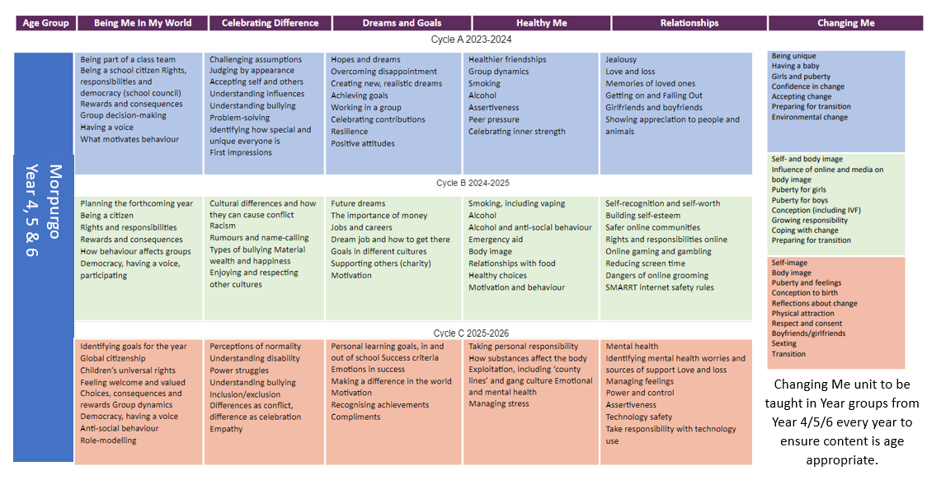
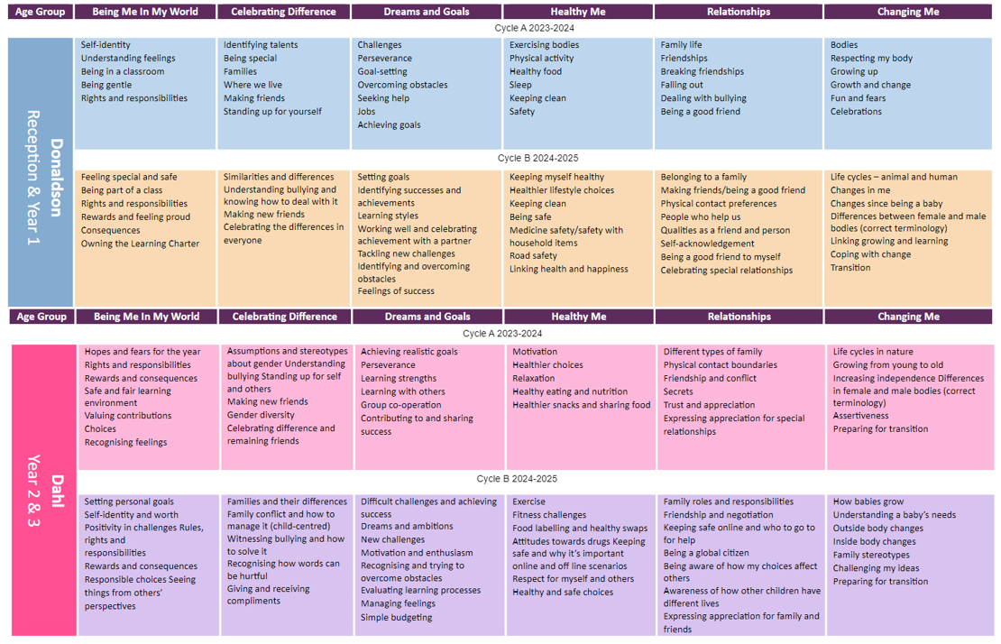
Jigsaw Curriculum Overview:
Appendix 3

Relationships Education in Primary schools – DfE Guidance 2019
The focus in primary school should be on teaching the fundamental building blocks and characteristics of positive relationships, with particular reference to friendships, family relationships, and relationships with other children and with adults. The references R3/H5 etc can be cross-referenced on the Jigsaw mapping documents and Puzzle Maps to show which lessons throughout Jigsaw contribute to which statutory outcomes. All statutory outcomes are covered in the Jigsaw 3-11 Programme.
The guidance states that, by the end of primary school:
 | Pupils should know… | How Jigsaw provides the solution
Families and people who care for me | - R1 that families are important for children growing up because they can give love, security and stability.  - R2 the characteristics of healthy family life, commitment to each other, including in times of difficulty, protection and care for children and other family members, the importance of spending time together and sharing each other’s lives.  - R3 that others’ families, either in school or in the wider world, sometimes look different from their family, but that they should respect those differences and know that other children’s families are also characterised by love and care.  - R4 that stable, caring relationships, which may be of different types, are at the heart of happy families, and are important for children’s security as they grow up.  - R5 that marriage represents a formal and legally recognised commitment of two people to each other which is intended to be lifelong (Marriage in England and Wales is available to both opposite sex and same sex couples. The Marriage (Same Sex Couples) Act 2013 extended marriage to same sex couples in England and Wales. The ceremony through which a couple get married may be civil or religious).  - R6 how to recognise if family relationships are making them feel unhappy or unsafe, and how to seek help or advice from others if needed | All of these aspects are covered in lessons within the Puzzles  - Relationships  - Changing Me  - Celebrating Difference  - Being Me in My World
Caring friendships | - R7 how important friendships are in making us feel happy and secure, and how people choose and make friends  - R8 the characteristics of friendships, including mutual respect, truthfulness, trustworthiness, loyalty, kindness, generosity, trust, sharinginterests and experiences and support with problems and difficulties  - R9 that healthy friendships are positive and welcoming towards others and do not make others feel lonely or excluded  - R10 that most friendships have ups and downs, and that these can often be worked through so that the friendship is repaired or even strengthened, and that resorting to violence is never right  - R11 how to recognise who to trust and who not to trust, how to judge when a friendship is making them feel unhappy or uncomfortable, managing conflict, how to manage these situations and how to seek help and advice from others, if needed | All of these aspects are covered in lessons within the Puzzles  - Being Me in My World  - Celebrating DIfference  - Relationships
Respectful relationships | - R12 the importance of respecting others, even when they are very different from them (for example, physically, in character, personality or backgrounds), or make different choices or have different preferences or beliefs  - R13 practical steps they can take in a range of different contexts to improve or support respectful relationships  - R14 the conventions of coutesy and manners  - R15 the importance of self-respect and how this links to their own happiness  - R16 that in school and in wider societythey can expect to be treated with respect by others, and that in turn they should show due respect to others, including those in positions of authority  - R17 about different types of bullying (including cyberbullying), the impact of bullying, responsibilities of bystanders (primarily reporting bullying to an adult) and how to get help  - R18 what a stereotype is, and how stereotypes can be unfair, negative or destructive  - R19 the importance of permission-seeking and giving in relationships with friends, peers and adults | All of these aspects are covered in lessons within the Puzzles  - Being Me in My World  - Celebrating Difference  - Dreams and Goals  - Healthy Me  - Relationships  - Changing Me
Online relationships | - R20 that people sometimes behave differently online, including by pretending to be someone they are not.  - R21 that the same principles apply to online relationships as to face-to-face relationships, including the importance of respect for others online including when we are anonymous.  - R22 the rules and principles for keeping safe online, how to recognise risks, harmful content and contact, and how to report them.  - R23 how to critically consider their online friendships and sources of information including awareness of the risks associated with people they have never met.  - R24 how information and data is shared and used online. | All of these aspects are covered in lessons within the Puzzles  - Relationships  - Changing Me  - Celebrating Difference
Being safe | - R25what sorts of boundaries are appropriate in friendships with peers and others (including in a digital context).  - R26 about the concept of privacy and the implications of it for both children and adults; including that it is not always right to keep secrets if they relate to being safe.  - R27 that each person’s body belongs to them, and the differences between appropriate and inappropriate or unsafe physical, and other, contact.  - R28 how to respond safely and appropriately to adults they may encounter (in all contexts, including online) whom they do not know.  - R29 how to recognise and report feelings of being unsafe or feeling bad about any adult.  - R30 how to ask for advice or help for themselves or others, and to keep trying until they are heard,  - R31 how to report concerns or abuse, and the vocabulary and confidence needed to do so.  - R32 where to get advice e.g. family, school and/or other sources. | All of these aspects are covered in lessons within the Puzzles  - Relationships  - Changing Me  - Celebrating Difference

Physical health and mental well-being education in Primary schools – DfE Guidance
The focus in primary school should be on teaching the characteristics of good physical health and mental wellbeing. Teachers should be clear that mental well-being is a normal part of daily life, in the same way as physical health.
By the end of primary school:
 | Pupils should know | How Jigsaw provides the solution
Mental wellbeing | - H1 that mental wellbeing is a normal part of daily life, in the same way as physical health.  - H2 that there is a normal range of emotions (e.g. happiness, sadness, anger, fear, surprise, nervousness) and scale of emotions that all humans experience in relation to different experiences and situations.  - H3 how to recognise and talk about their emotions, including having a varied vocabulary of words to use when talking about their own and others’ feelings.  - H4 how to judge whether what they are feeling and how they are behaving is appropriate and proportionate.  - H5 the benefits of physical exercise, time outdoors, community participation, voluntary and service-based activity on mental well-being and happiness.  - H6 simple self-care techniques, including the importance of rest, time spent with friends and family and the benefits of hobbies and interests.  - H7 isolation and loneliness can affect children and that it is very important for children to discuss their feelings with an adult and seek support.  - H8 that bullying (including cyberbullying) has a negative and often lasting impact on mental well-being.  - H9 where and how to seek support (including recognising the triggers for seeking support), including whom in school they should speak to if they are worried about their own or someone else’s mental well-being or ability to control their emotions (including issues arising online).  - H10 it is common for people to experience mental ill health. For many people who do, the problems can be resolved if the right support is made available, especially if accessed early enough. | All of these aspects are covered in lessons within the Puzzles  - Healthy Me  - Relationships  - Changing Me  - Celebrating Difference
Internet safety and harms | - H11 that for most people the internet is an integral part of life and has many benefits.  - H12 about the benefits of rationing time spent online, the risks of excessive time spent on electronic devices and the impact of positive and negative content online on their own and others’ mental and physical wellbeing.  - H13 how to consider the effect of their online actions on others and knowhow to recognise and display respectful behaviour online and the importance of keeping personal information private.  - H14 why social media, some computer games and online gaming, for example, are age restricted.  - H15 that the internet can also be a negative place where online abuse, trolling, bullying and harassment can take place, which can have a negative impact on mental health.  - H16 how to be a discerning consumer of information online including understanding that information, including that from search engines, is ranked, selected and targeted.  - H17 where and how to report concerns and get support with issues online. | All of these aspects are covered in lessons within the Puzzles  - Relationships  - Healthy Me
Physical health and fitness | - H18 the characteristics and mental and physical benefits of an active lifestyle.  - H19 the importance of building regular exercise into daily and weekly routines and how to achieve this; for example, walking or cycling to school, a daily active mile or other forms of regular, vigorous exercise.  - H20 the risks associated with an inactive lifestyle (including obesity).  - H21 how and when to seek support including which adults to speak to in school if they are worried about their health. | All of these aspects are covered in lessons within the Puzzles  - Healthy Me
Healthy eating | - H22 what constitutes a healthy diet (including understanding calories and other nutritional content).  - H23 the principles of planning and preparing a range of healthy meals.  - H24 the characteristics of a poor diet and risks associated with unhealthy eating (including, for example, obesity and tooth decay) and other behaviours (e.g. the impact of alcohol on diet or health). | All of these aspects are covered in lessons within the Puzzles  - Healthy Me
Drugs, alcohol and tobacco | - H25 the facts about legal and illegal harmful substances and associated risks, including smoking, alcohol use and drug-taking | All of these aspects are covered in lessons within the Puzzles  - Healthy Me
Health and prevention | - H26 how to recognise early signs of physical illness, such as weight loss, or unexplained changes to the body.  - H27 about safe and unsafe exposure to the sun, and how to reduce the risk of sun damage, including skin cancer.  - H28 the importance of sufficient good quality sleep for good health and that a lack of sleep can affect weight, mood and ability to learn.  - H29 about dental health and the benefits of good oral hygiene and dental flossing, including regular check-ups at the dentist.  - H30 about personal hygiene and germs including bacteria, viruses, how they are spread and treated, and the importance of handwashing.  - H31 the facts and science relating to immunisation and vaccination | All of these aspects are covered in lessons within the Puzzles  - Healthy Me
Basic first aid | - H32 how to make a clear and efficient call to emergency services if necessary.  - H33 concepts of basic first-aid, for example dealing with common injuries, including head injuries. | All of these aspects are covered in lessons within the Puzzles  - Healthy Me
Changing adolescent body | - H34 key facts about puberty and the changing adolescent body, particularly from age 9 through to age 11, including physical and emotional changes.  - H35 about menstrual wellbeing including the key facts about the menstrual cycle. | All of these aspects are covered in lessons within the Puzzles  - Changing Me  - Healthy Me

