Geography Curriculum Overview
 | Term 1 | Term 2 | Term 3 | Term 4 | Term 5 | Term 6
Reception | Me and My World  Foci: PSED/ CLL/ UW  Our local area, exploring the school grounds and Cowbit as a village. | Celebrations  Foci: UW/EAD  What country do we live in? | Exploration  Foci: UW/ EAD/ PSED  Exploring simple maps and photographs | Amazing Animals  Foci: UW  Comparing our local area to stories from around the world | Grow  Foci: UW/PD  Seasons and signs of summer | Once Upon a Time  Foci: CLL/ EAD  What’s our capital city? Simple Map work and stories from the capital
Year 1 / 2  Cycle A | Wonderful Weather  How does the weather affect our lives?  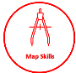  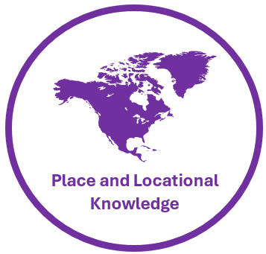 |  |  | On the Farm  What type of farms are there in Cowbit?  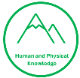 |  | Coastal Explorers  Would you rather live in Cowbit or a coastal town?  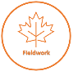  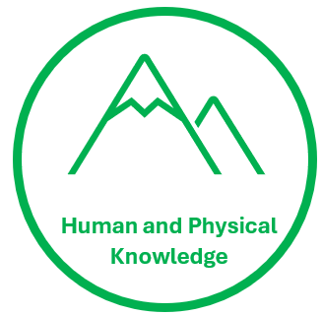
Year 1 / 2  Cycle B | Location Location!  How is London similar or different to Cowbit?  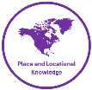 |  | Hot, hot, hot!  What’s it like living in Brazil? |  | Polar Opposites  What’s it like living in Antarctica?
Year 3 / 4  Cycle A | Our Local Area  How has our area changed over time? |  | Life in the City  Where do people live and why? |  | Our World  Why are jungles so wet and deserts so dry?
Year 3 / 4  Cycle B | Active Planet  How do natural disasters occur and what impact do they have? |  | Green Team  How can we live more sustainably? |  | Sunshine State  How does the geography of Florida compare to where I live?
Year 5 / 6  Cycle A |  | World Trade  What is fair trade? |  |  | Exploring Spain  How does the geography of Spain compare to where I live? | Climate Control  How is climate change affecting the world?
Year 5 / 6  Cycle B |  | Magnificent Mountains  How are mountains formed and are all mountains the same? |  |  | Go with the Flow  What is a river and why are they so important? | Rainforest Explorers  How is India saving the tiger population?

