
Cowbit St Mary’s Church of England Primary School
Newsletter- Term 5

As we draw to the end of another term, it’s time to have a break before the busy summer term is upon us. We have lots of things going on next term. On 9th July we have a ‘move up day’ where the children will all move up a year for the day so that could mean moving to their new class or staying where they are and meeting the new children joining them. There will also be transition days for all the Year 6 leavers at their new schools, and some sessions where children joining us in Reception in September will be able to come along, meet teachers and make some new friends.
Morpurgo Class in Term 5
This term Morpurgo learnt about the Vikings. We wanted to investigate whether they were raiders, traders or settlers. We discovered that depending on which viewpoint history was written from, they could either be raiders or traders. After a few battles with the Anglo-Saxons, some Vikings settled in England and has become part of our history.
During literacy we had to write a battle scene between the Vikings and the Norwegians. In order to explore the atmosphere of the battle, we enacted the scene through drama. We could really feel the emotion of the moment.
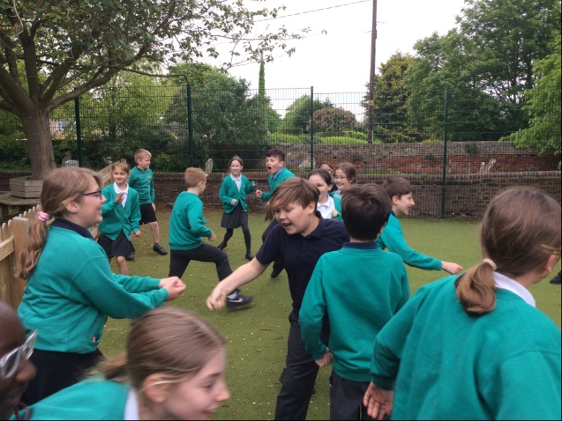
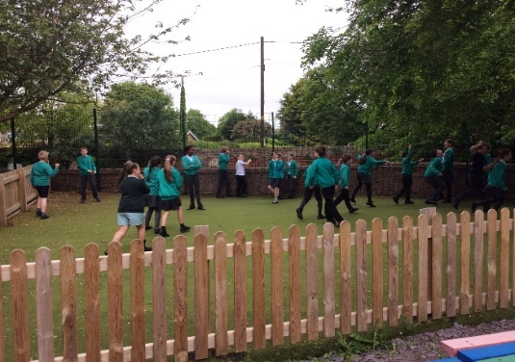
Dahl Class in Term 5
Dahl class have been learning about the Amazon Rainforest this term. They have researched what the habitat and climate are like, threats to the rainforest and its indigenous people and have even created setting and character descriptions in their writing lessons. The final week of term has been our Art Week and we have created some beautiful tropical pieces of art, including painted clay leaves.
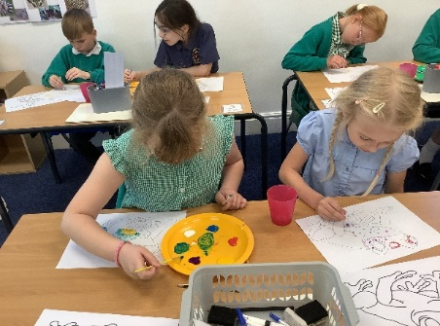
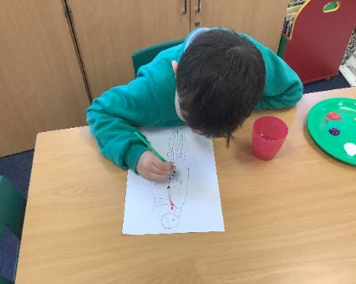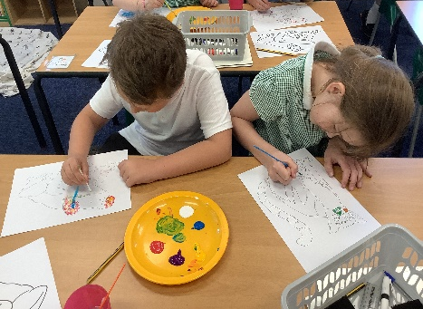
Donaldson Class in Term 5
Donaldson class have been learning about the Wright Brothers. We have used historical sources like photos and diaries to find out as much as we could and wondered why they were important people. In science, we have learnt about materials, and experimented to see which ones float or sink. For English this term, we have used visual literacy, using the film Up to write a recount. In DT, we have made moving pictures, here are some of the photos of us making our pop-up bunnies.
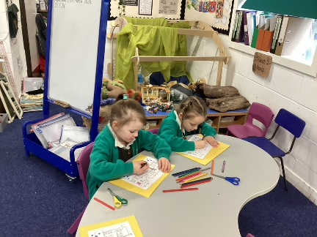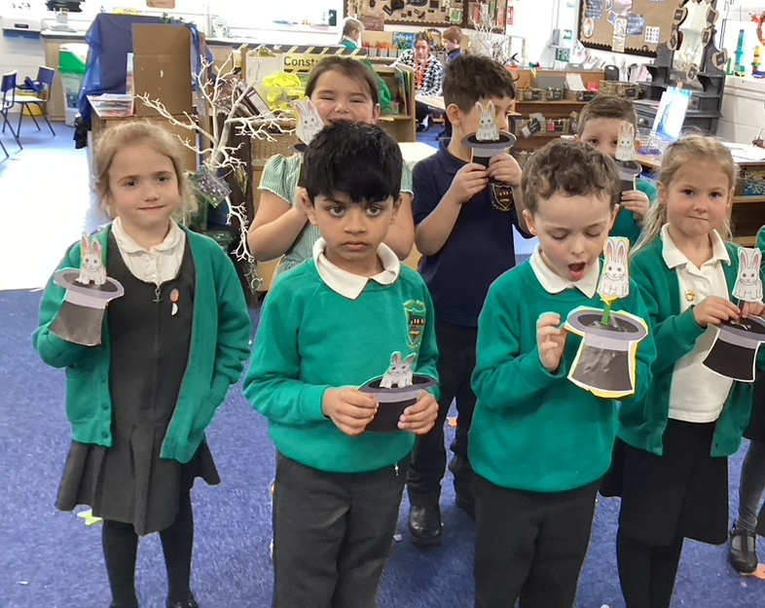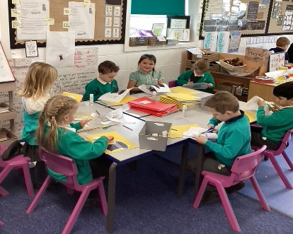
Uniform
We are currently in the process of moving our uniform shop online. However, we have a lot of uniform in stock in school. A lot of the sizes are still available but once there is no stock in school it will need to be ordered online. You are only able to order online once that size is out of stock in school. With a new school year coming, we realise that this is the time people will be thinking of purchasing new uniform. Uniform order sheets are available from the office, and we encourage you to order soon. If you bring in your completed order form, we can advise you whether you need to order online, or we can fulfil your order within school and then payment can be made once it has been determined where you need to order from. You can also check sizes if you wish to see if they fit.
Once all stocks are used, it will be a very easy straight forward process to order uniform. Please bear in mind that if you need to order online it will take longer for delivery. The online service will deliver directly to your door within 3 weeks but please note there is a charge for postage. There is an option to get uniform delivered to school for free which will take approximately 2 weeks. During the summer holidays it will be a direct home delivery service only so you may want to order this before the start of July.
School Dinners
As you know we are changing meal providers and when the children come back in June they will be trying the new dinners. We hope the extra choices and food will be enjoyed by as many children as possible. The order deadline for each week is the Tuesday before the week you are ordering for. So for the week beginning 3rd June, the order deadline is 28th May 2024 but there will be no one in school after today so please contact school as soon as you can if you are having any problems.
Attendance
Each week every pupil who has 100% attendance for the week gets a raffle ticket. This term there has been 6 chances to get a ticket, and therefore a possible 6 entries into the draw. The winning tickets have been picked at random today.
The winners of this term’s attendance prizes are:
Key Stage 1 – Andy Morrison
Key Stage 2 – Shay Bycraft
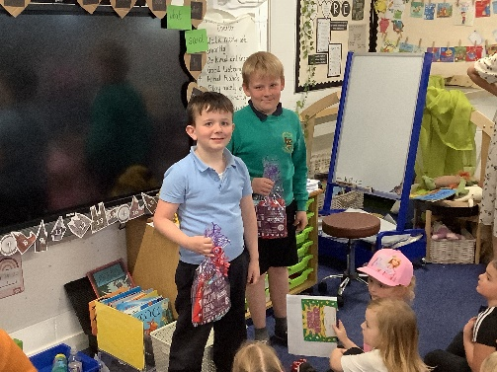
They win a £20 voucher for the Cinema at South Holland Centre and some snacks to enjoy.
Breakfast Club
Breakfast Club is now run by Mrs Ross and the children are enjoying all the new activities she has been doing with them. Breakfast Club is open at 7.30, from Monday to Friday during term time, the price is £3.50, and breakfast and entertainment is included. There is no need to book so you can just turn up on the day.
After School Clubs for Term 6
Wednesday – Summer Multisports – Year 3, Year 4, Year 5 and Year 6.
Friday – Summer Multisports – Reception, Year 1 and Year 2.
Please message Mrs Matthews on Class Dojo to sign up for a club.
Friends of Cowbit
This year’s School Fete will be on 6th July. The Friends of Cowbit really need some help with organising this and running stalls. Please contact Mrs Cornwell or Mrs Matthews if you can offer any help with this – even if it just helping getting things ready or helping on the day. All help is appreciated, and the money raised by Friends of Cowbit is used to help fund things for the children. This year Friends of Cowbit have purchased laptops, books and treats.
Year 6 Leaver’s Event
The Year 6 children will be also be raising funds for their leaver’s event with running the stock at the School Fete. Details of their leaver’s event will be provided nearer the time.
Parent Governor
Following our first letter for a parent governor, nobody has come forward for the role. We will shortly be advertising the governor role again but if you are interested, please speak to Mr Chris Elliott, our chair of governors. The Governing Body, with the Head Teacher, has overall responsibility for the running of the school. Governing bodies have three core strategic functions.
· Ensuring clarity of vision, ethos and strategic direction.
· Holding the Head Teacher to account for the educational performance of the school and its pupils.
· Overseeing the financial performance of the school and making sure its money is well spent.
The role of governor can be demanding but very rewarding. Parent governors serve a four-year term of office.
Swimming
Years 4/5/6 will continue swimming on Mondays. We kindly ask for a £3 contribution towards each session to help with transport costs which have risen to £105 per session. The bus will leave at 12.30pm for a 1pm lesson. Please make sure your child has their swimming kit every Monday, this will be instead of P.E on a Friday. Morpurgo class will still need to come to school in their P.E kit on a Wednesday please.
Classes
We currently have an advert out for a new teacher as we are looking to change to a 4 class model for September. We are hoping to have a Reception class, a year 1 and year 2 class, a year 3 and year 4 class, and a year 5 and year 6 class.
This will help us reduce the class size in Years 4, 5, and 6 and enable us to offer a more tailored curriculum. We are really hopeful that we will be able to appoint someone, and we will update you as soon as we able to.
Diary dates for Term 6.
- 6th June – Outside class group photos.
- 3rd June – Multiplication check week for year 4.
- 10th June – New intake (Starting in September) – Parent’s evening.
- 10th June – Phonics screening check week for year 1 and year 2.
- 19th June – Spalding Academy Transition Day for SEND Children.
- 25th June – New intake – induction afternoon.
- 26th June Sports Day – depending on the weather.
- 28th June – Spalding Academy Day for Year 6 children.
- 2nd July – New intake – induction afternoon.
- 3rd July – Back-up Sports Day – if the first one has been cancelled.
- 6th July – Summer Fete.
- 5th July – Spalding High School Transition Day for Year 6.
- 5th July – Spalding Grammar School Transition Day for Year 6.
- 9th July – new Intake – Teddy Bear’s Picnic and induction afternoon.
- 9th July – Move up day for Reception to Year 5.
- 9th July – The Deepings School Transition Day for Year 6.
- 10th July – The Deepings School Transition Day for Year 6.
- 16th July – Identity workshop for Year 6 .
- 19th July – End of term – break up for Summer.
We hope you have a wonderful sunny holiday. Term 6 starts on Monday 3rd June 2024.
Kind Regards,
Mrs Leonard

